Wireless Matrix AutoTests
By Paul Rogers ( paulr@wrx-ca.com )

Background

Resource-rich Northern Alberta is home to many oil and gas wells. However, the remote location makes it difficult to monitor and adjust parameters associated with oil and gas production. A solution is to a remote monitoring device that can transmit data, and receive adjustments from a central monitoring station. Of course wire-based telecommunication is rarely available.

By using satellite communication as the transmission medium, the Wireless Matrix Remote Data Monitoring (RDM) system allows operational settings to be monitored remotely and adjustments to be made.

The measurement devices on the oil well, frequently called Remote Terminal Units (RTU), use a variety of protocols to communicate. The most widely used is MODBUS.

Wireless Matrix supplies a device (called the Processor Assisted Connector, or PAC ) that communicates with the RTUs on site, and transmits the data, via satellite, to servers located at the clients main office. This data is then made available to users via a web interface. A notification system, via email, fax or phone is available when a particular reading is outside of normal operational limits. A JMS feed and web services are also available to help integration with clients’ other applications.

Simplified Block Diagram of the RDM System
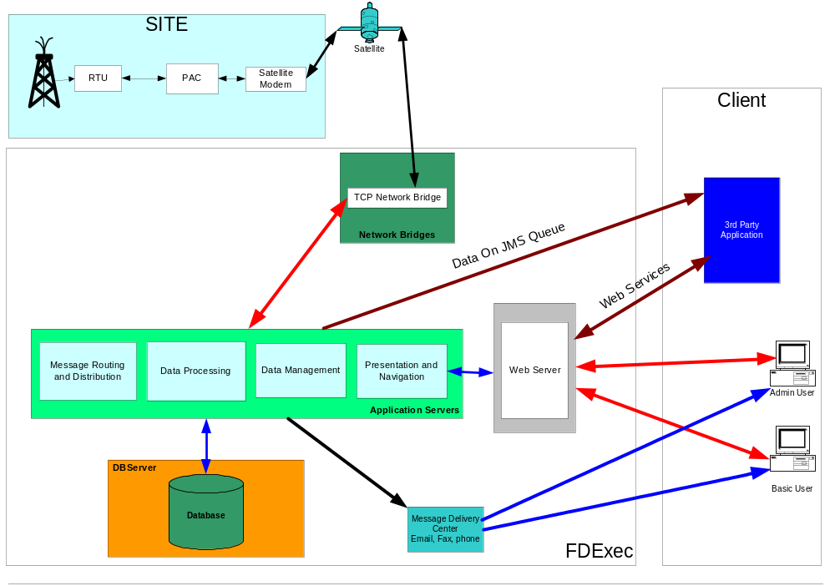

The Testing Challenge

Some automated tests for the web based GUI did exist. These were written using Segue SilkTest, but provided little in the way of in-depth testing. A decision was made to stop using Silk and switch to Ruby, using a modified form of the Web Testing With Ruby (wtr) IEController.

The Web Testing With Ruby Controller

The WTR project uses Ruby to control Internet Explorer using its OLE interface. Using this interface we are able to access the DOM. This means that if you can do something in javascript, we can do it in Ruby. The advantage here is that we are in full control of Internet Explorer, and can access almost all the objects in the page.

The Auto Test Structure

The structure of the auto test code was such that there were 3 distinct layers.
Layer 1
The lowest layer, is the IEController, and other classes, such as loggers.

Layer 2
This is called the page access layer. Here there are classes that contain code to access individual web pages. For example, in the application under test (AUT) there is a login page, a create user page, and an edit user page. Classes written in Ruby contain code that can perform certain functions in the AUT, such as a class that logs into the application, a class to edit a user and a class to assign access rights to a user.

These classes contain no data. For example, the login class doesn’t know what username to login with. Layer 3 supplies that data.

Layer 3
This is called the test layer. It contains the data needed to perform a test. It calls the Layer 2 classes.

Layer 2 also knows how to handle error messages the application may generate. For example when an invalid username is entered on the login page, the login class will detect the error message, and pass the problem to the Test Layer.

This means the same Layer 2 classes can be used for both happy path testing and for negative testing. In the negative case, Layer 3 would expect Layer 2 to return a failure, and could then check to see if the test failed for the correct reason, by accessing the error messages that Layer 2 has scraped from the browser.

Embedded Testing

In addition to the web interface, the RDM system consists of the PAC – a small embedded device that communicates with measuring equipment using the MODBUS protocol.
Using Ruby, various tests were developed to test part of its administrative interface (a command line system – similar to FTP).

These tests were contained in an Excel spreadsheet. A Ruby script would read commands from Excel (again using the OLE interface) and send them to the PAC. The script would then compare the response from the PAC with the expected result, also held in the spreadsheet.
While this provided a lot of test coverage (the auto test took approx 1 hour to run, manually it would take 8 hours) it didn’t actually test the reason the PAC is used – namely reading data from RTUs.

A MODBUS simulator was written, using Ruby, with a FOX (FXRuby) gui. This allows mock data to be applied to the PAC. Since the simulator can be controlled remotely, it is incorporated into auto tests that exercise the PACs ability to read data, respond to error conditions, and generate alarms when the input data exceeds a pre-determined threshold.

Screen Shot of the RTU Simulator

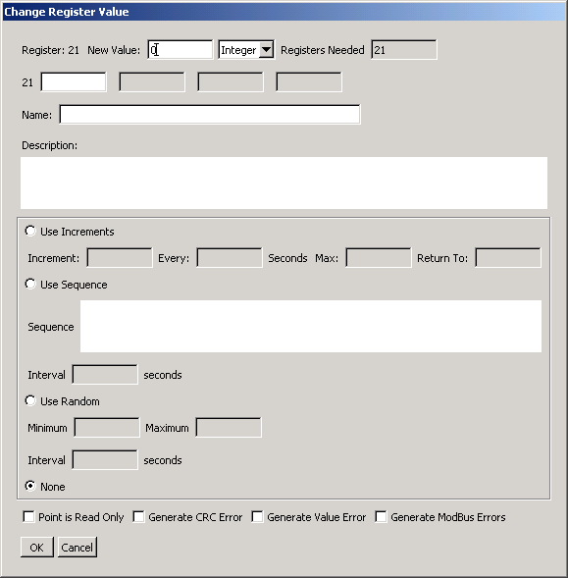
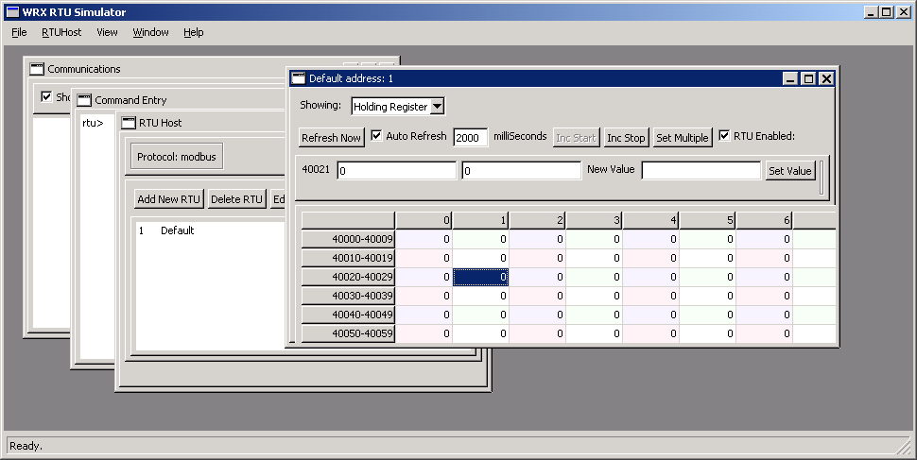

WebServices

During integration testing at a customers’ premises, the customer determined they needed a Web Services interface.

The development group created some prototype web services, and used Ruby to write a client to test these services. For these tests, Ruby’s unit testing framework, Test::Unit, was used.

These web service tests were expanded by the QA group to cover over 1000 different test cases. The entire set of tests take just minutes to run.

Testing Data Feeds

As shown in the diagram above, it can be seen that, the data from the FDExec system is available on a JMS queue as well as the web browser. Also, emails can be sent when alarm conditions are encountered.

To test the JMS Queue, a Java proxy was written by the development group. This connects to a queue, and prints any arriving data to the console. A Ruby client was written that received this data using a pipe. This data was then available in the Ruby autotest system.

The emails generated during alarm conditions contained both plain text email, and email with MIME attachments. The MIME data contained data useful for testing, so a mime decoder was written, which allowed access to this data.

The End-To-End Tests

From the begining, it was apparent that correct operation of the whole system could only be determined when all components were used. Once the Modbus Simulator, Pac Tests, Web Services Tests and Web tests were written, it was a relatively simple matter to combine them to produce an automated test of the entire system. Once again, Excel was used to hold the test data and Ruby classes were written to access the data and expected results.

The end-to-end tests were complicated by the unpredictable response of the satellite transmission path. Where the tests expected a particular value, and the current value is not correct, the tests will cycle for a pre-determined length of time, and only when this timeout period has expired and the current value is still not correct will the test be deemed to have failed.

Diagram Showing the PCs in the Test System, and what they are used for
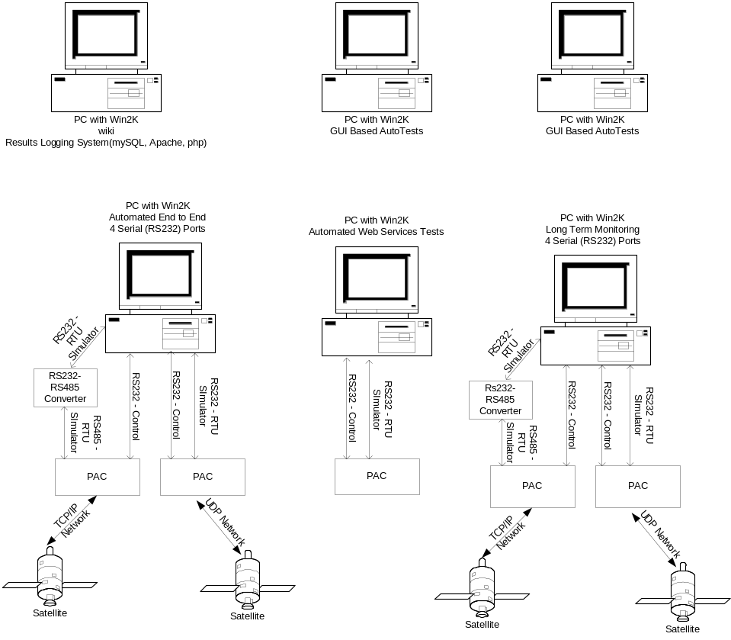

Reporting the Test Results

Although comprehensive testing was being performed, there was little evidence of this outside of the QA group. The logs generated during autotests provided good information to track down problems, but were not suitable for a wider audience.
To raise the visibility of the tests being performed, the QA group developed a logging/reporting system, using Apache, PHP and mySQL.

When a test runs, it logs the result into the database, and a web front end allows project stakeholders to determine what tests have been run, the pass/failure rate and other information.

Screen Shot of the Results page from the Logging System
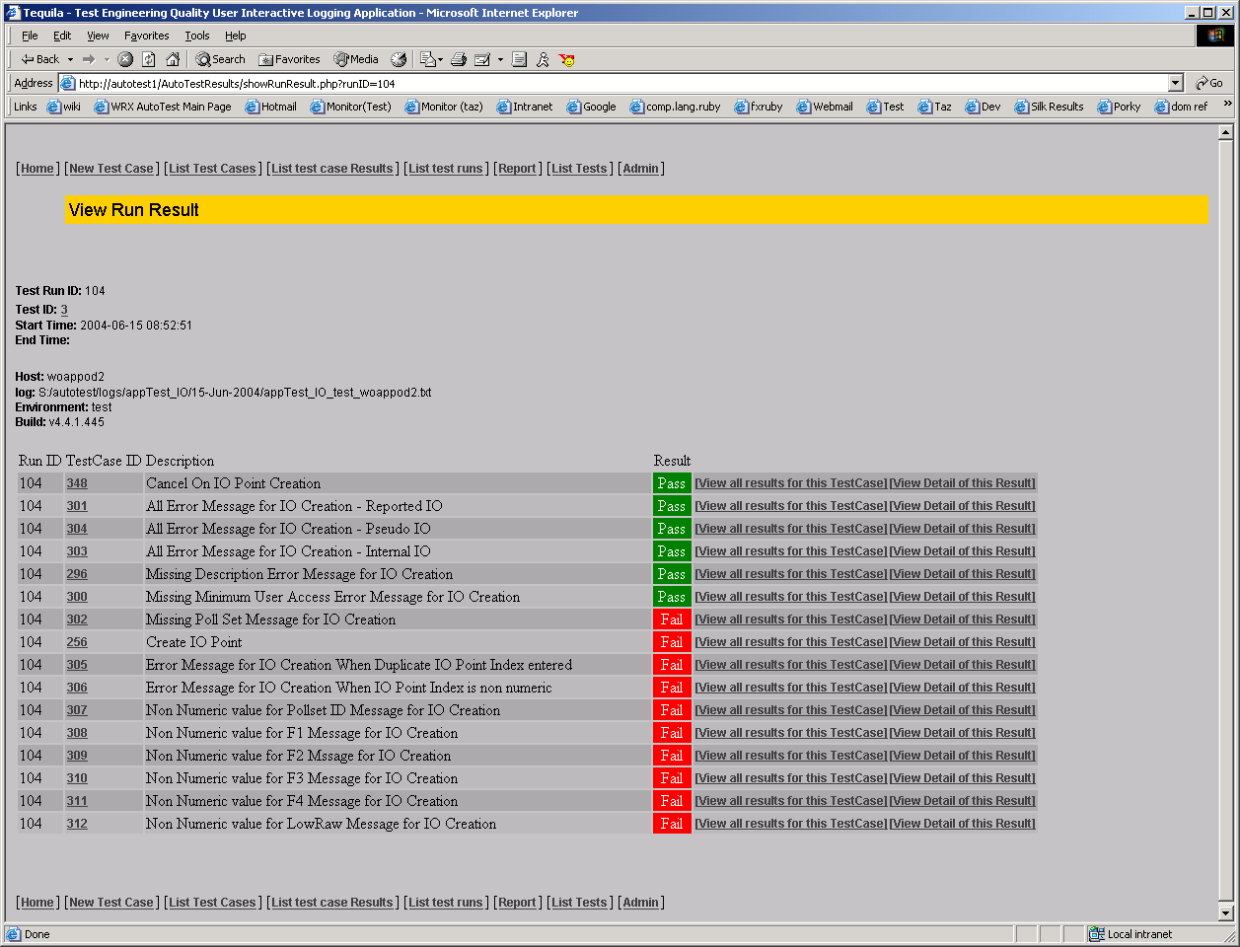

Documenting the Test Code

During development, it became clear that a formal documentation system was needed for the test code. The simplest solution was to use RDoc, similar to Javadocs, but for Ruby. RDoc extracts tagged comments from the source code, and generates web pages, with details of files, classes and methods. The documents are generated every night, using a batch file.

The Numbers

- The IEController we use is 1500 lines long, with about 40 methods
- The code for the createuser class is about 400 lines (this also does editUser, as it’s the same page). - Please note that I write very verbose code, with lots of white space (as I think this helps us to have very readable code).
- We have a total of 131 files for our autotests, and 41,000 lines of code. About 7,000 lines of this is the simulator

Conclusions

Here are some of the advantages we have realized using a general purpose scripting language over a dedicated testing tool.

- free license, no purchase cost for the tool
- large community, with language support from the comp.lang.ruby group
- large well-documented libraries
- ease of code development using a “real” programming language
- readability and maintainability.

The wide range of testing that was achieved using Ruby, and the short time in which it happened (7 months, which includes time for manual exploratory testing of both the PAC and the FDExec web system) shows what a versatile language it is.

Ruby has worked very well for us, as it is not cost-prohibitive, uses a real programming language with a large community of practice to draw on, is robust and easy to learn. It also allows testers to either write test cases in a procedural manner which closely mirrors how testers design manual test cases or in a more object orientated fashion. We were not able to realize this variety, depth, complexity and speed of development using a proprietary testing language.

References

RDoc - http://rdoc.sourceforge.net/
Modbus - http://www.modbus.org/
Wireless Matrix - http://www.wirelessmatrixcorp.com
FXRuby - http://fxruby.sourceforge.net/

Behind The Scenes (Testing Web Services With Ruby) - https://www.stickyminds.com/sitewide.asp?sid=1&sqry=%2AZ%28SM%29%2AJ%28MIXED%29%2AR%28relevance%29%2AK%28simplesite%29%2AF%28ruby%29%2A&sidx=4&sopp=10&ObjectId=7521&Function=DETAILBROWSE&ObjectType=MAGAZINE

WTR – Web Testing With Ruby - http://www.clabs.org/wtr/index.cgi?page=/ClIEController

